XSS Attack Detection Using Machine Learning

Abstract

Machine learning steps into the role of spotting Cross-Site Scripting threats here. At its heart sits a Random Forest model, shaped to tell apart harmful web traffic from safe user activity. Before training begins, data gets cleaned, transformed, and then divided into eight parts for learning, two for testing. Evaluation leans on accuracy numbers, alongside a confusion matrix and common performance indicators. From start to finish, each phase unfolds: intake of raw logs, preparation work, modelling effort, and up to assessment results.

Introduction

Security risks surround web apps constantly; cross-site scripting stands out due to its staying power. Injecting harmful code into web pages happens when visitors unknowingly run it through their browser - execution opens doors: private details may vanish, navigation gets hijacked, control shifts without permission. Outcomes shift widely - from small leaks to total takeover. Relying on people alone won’t work on a scale. Consider typical traffic levels for an average site - review speed lags, attention wavers, flaws slip past unnoticed. Here’s when machine learning becomes useful - instead of crafting manual rules, a trained system recognises patterns tied to harmful inputs and marks them without help. A clear, transparent workflow is created for this task: using tagged traffic records, a Random Forest method learns from examples, then checks how well it spots actual XSS attacks.

Problem Statement
The goal of this project is to classify web inputs as either malicious (XSS attack) or normal. The challenge lies in handling textual data and converting it into a format suitable for learning machines. Additionally, the model must generalize well with unseen data.

Dataset Description
The dataset used contains 461 records related to XSS attacks. It includes features such as application names, permissions, APIs, and other attributes. Each record is labelled as either malicious (1) or benign (0). The dataset is relatively small, making it suitable for beginner-level machine learning experiments.

Data Preprocessing
While data preprocessing plays a significant role in machine learning, the initial data might require modifications prior to use. Due to the nature of the dataset that contains words rather than numeric values, data conversion is necessary. This can be achieved by replacing each unique value with an integer using labelling techniques. Any missing values in the rows will be examined and either imputed or eliminated.

Feature Selection
Features are the input variables used by the model. The label column is separated from the rest of the data. The remaining columns form the feature set (X), while the label forms the target variable (y). This separation is essential for training the model.

Train-Test Split
The dataset is divided into training and testing sets. 80% of the data is used for training, while 20% is used for testing. This ensures that the model is evaluated on unseen data. It helps prevent overfitting and provides a realistic performance measure.

Model Selection
The Random Forest algorithm is used in this project. It is an ensemble method that combines multiple decision trees. Each tree makes a prediction, and the result is based on majority voting. This improves accuracy and reduces overfitting.

Model Training
The model is trained using the training dataset. It learns patterns by analysing relationships between features and labels. This step is where the model builds its internal logic.

Prediction
After training, the model is used to predict labels for the test dataset. The predicted values are compared with actual values to evaluate performance.

Evaluation Metrics
- Accuracy measures the percentage of correct predictions.
- The classification report includes precision, recall, and F1-score.
- The confusion matrix shows correct and incorrect classifications.
- These metrics provide a complete view of model performance.

Results Discussion
- The model performs well on the dataset with high accuracy.
- The confusion matrix shows that most predictions are correct.
- Some misclassifications may occur due to limited data.
- Overall, the model demonstrates good capability in detecting XSS attacks.

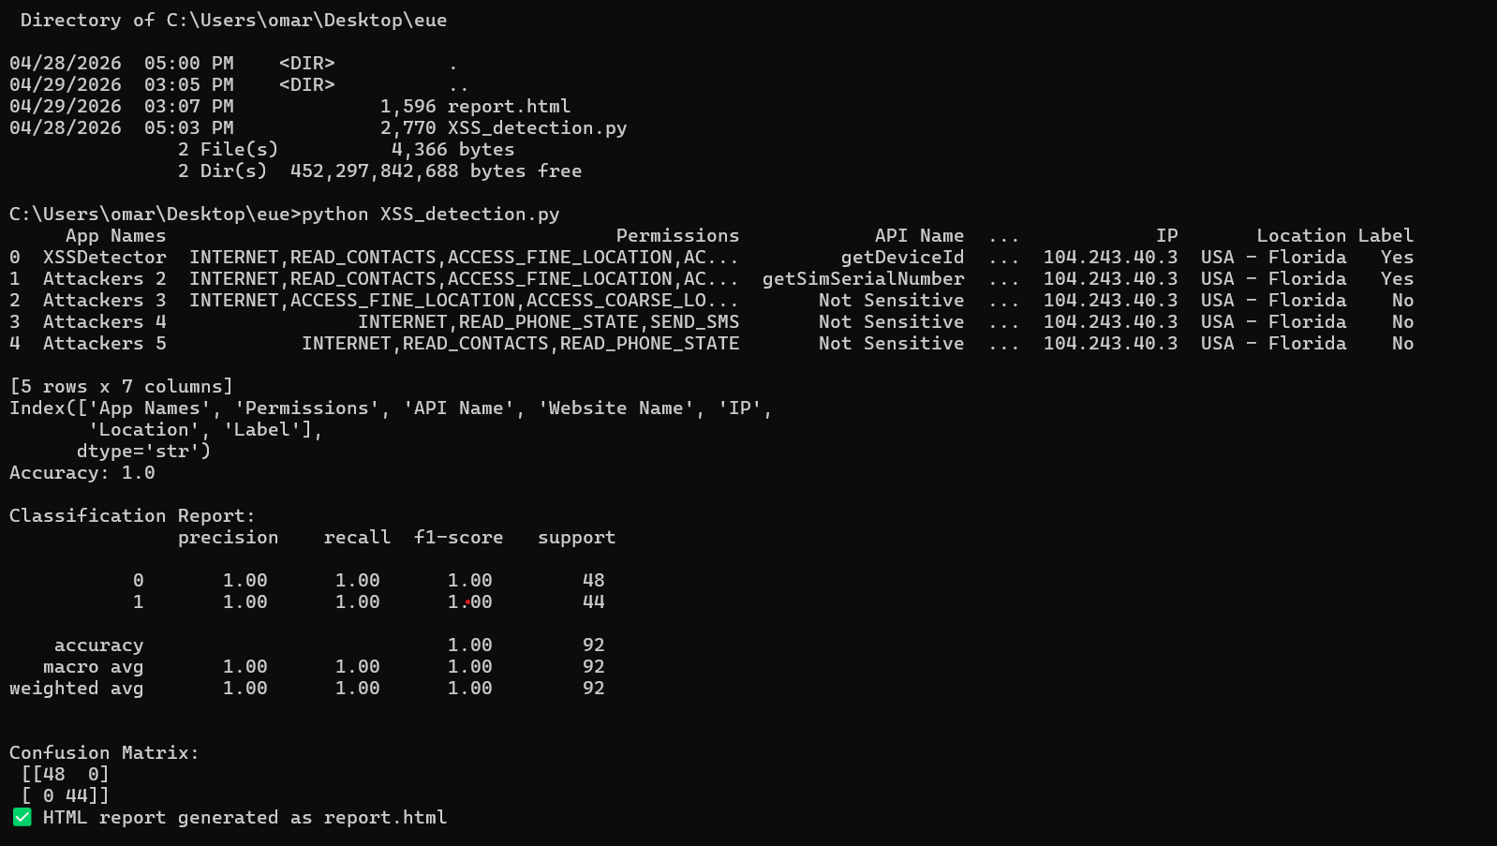
HTML Report :
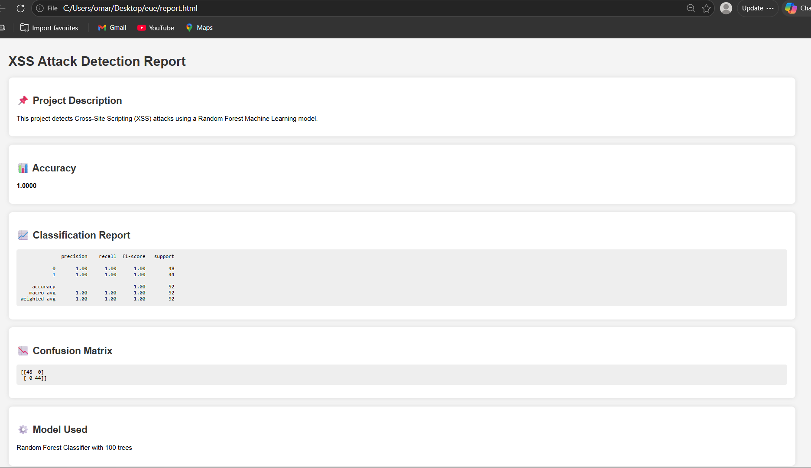

Conclusion
This project successfully demonstrates the use of machine learning in cybersecurity. The Random Forest model provides reliable performance. Future work can include using larger datasets and deep learning models. Additional features and tuning can further improve accuracy.

Future Work
- Use larger and more diverse datasets.
- Apply deep learning techniques like LSTM or CNN.
- Deploy the model as a web application.
- Improve feature engineering techniques.

References
Scikit-learn documentation
Pandas documentation
Kaggle datasets : XSS attacks Dataset
Research papers on XSS detection

Code :
import pandas as pd
from sklearn.model_selection import train_test_split
from sklearn.ensemble import RandomForestClassifier
from sklearn.metrics import classification_report, confusion_matrix, accuracy_score

# Load Excel file
data = pd.read_excel(r"C:\Users\omar\Desktop\XSS Attack Dataset with 461 entries.xlsx")

# Show structure
print(data.head())
print(data.columns)

# IMPORTANT: check column name for label
# change 'Label' if your file uses different name
label_column = "Label" # <-- change if needed

# Convert text to numbers
data = data.apply(lambda x: pd.factorize(x)[0])

# Split features and target
X = data.drop(label_column, axis=1)
y = data[label_column]

# Train-test split
X_train, X_test, y_train, y_test = train_test_split(
X, y, test_size=0.2, random_state=42
)

# Train model
model = RandomForestClassifier(n_estimators=100)
model.fit(X_train, y_train)

# Predict
y_pred = model.predict(X_test)

# Results
print("Accuracy:", accuracy_score(y_test, y_pred))
print("\nClassification Report:\n", classification_report(y_test, y_pred))
print("\nConfusion Matrix:\n", confusion_matrix(y_test, y_pred))

# Save results to HTML

accuracy = accuracy_score(y_test, y_pred)
report = classification_report(y_test, y_pred)
cm = confusion_matrix(y_test, y_pred)

html_content = f"""
<!DOCTYPE html>
<html>
<head>
<title>XSS Detection Report</title>
<style>
body {{
font-family: Arial;
margin: 40px;
background-color: #f4f4f4;
}}
h1, h2 {{
color: #333;
}}
.box {{
background: white;
padding: 20px;
margin-bottom: 20px;
border-radius: 10px;
box-shadow: 0 0 10px rgba(0,0,0,0.1);
}}
pre {{
background: #eee;
padding: 10px;
border-radius: 5px;
}}
</style>
</head>
<body>

<h1>XSS Attack Detection Report</h1>

<div class="box">
<h2>📌 Project Description</h2>
<p>This project detects Cross-Site Scripting (XSS) attacks using a Random Forest Machine Learning model.</p>
</div>

<div class="box">
<h2>📊 Accuracy</h2>
<p><strong>{accuracy:.4f}</strong></p>
</div>

<div class="box">
<h2>📈 Classification Report</h2>
<pre>{report}</pre>
</div>

<div class="box">
<h2>📉 Confusion Matrix</h2>
<pre>{cm}</pre>
</div>

<div class="box">
<h2>⚙️ Model Used</h2>
<p>Random Forest Classifier with 100 trees</p>
</div>

</body>
</html>
"""

# Save file
with open("report.html", "w", encoding="utf-8") as f:
f.write(html_content)

print("✅ HTML report generated as report.html")

Github link:
Omar106-07/math_xss

